

Draw it or lose it

# **CS 230 Project Software Design Template**

Version 1.0

## Table of Contents

**CS 230 Project Software Design Template**1

**Table of Contents**2

**Document Revision History**2

**Executive Summary**3

**Design Constraints**3

**System Architecture View**3

**Domain Model**3

**Evaluation**3

**Recommendations**5

## Document Revision History

| Version | Date | Author | Comments |
| --- | --- | --- | --- |
| 1.0 | 05/20/2021 | Alex Keith | To enable team play abilities and give out unique names ensuring only one instance. |

**Instructions**

Fill in all bracketed information on page one (the cover page), in the Document Revision History table, and below each header. Under each header, remove the bracketed prompt and write your own paragraph response covering the indicated information.

## Executive Summary

The software design problem is a four round, one minute guessing game where teams guess what is being drawn. The client requires that the game offer multi-team game play with unique player ids. The client wants only one instance of the game and to achieve this we must produce unique identifiers for each instance of the game, team, or player.

## Design Constraints

The client requires that there only be one instance of the each attribute of the game and requires that the game follow the play rules set, including multiteam play. This is possible with a singleton pattern.

## System Architecture View

Please note: There is nothing required here for these projects, but this section serves as a reminder that describing the system and subsystem architecture present in the application, including physical components or tiers, may be required for other projects. A logical topology of the communication and storage aspects is also necessary to understand the overall architecture and should be provided.

## Domain Model

The UML diagram includes classes related to The Gaming Room. This UML diagram demonstrated object-oriented programming. There are multiple instances of inheritance shown in the “Game”, “Team”, and “Player” class that inherit the “Entity” class. This helps establish the first steps of only having one instance of game attributes. Each class has its attributes and methods listed below and it gives an overview of how the program will run.

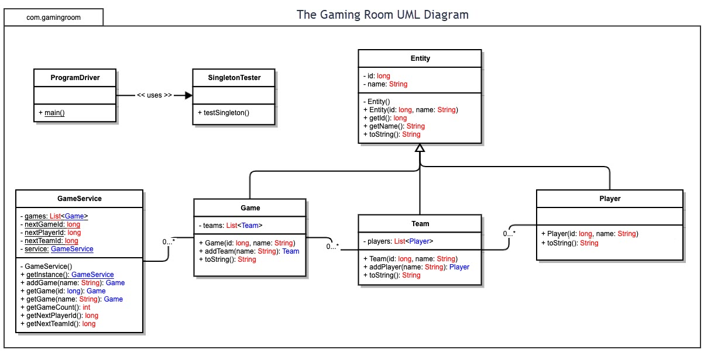

## Evaluation

Using your experience to evaluate the characteristics, advantages, and weaknesses of each operating platform (Linux, Mac, and Windows) as well as mobile devices, consider the requirements outlined below and articulate your findings for each. As you complete the table, keep in mind your client’s requirements and look at the situation holistically, as it all has to work together.

In each cell, remove the bracketed prompt and write your own paragraph response covering the indicated information.

| **Development Requirements** | **Mac** | **Linux** | **Windows** | **Mobile Devices** |
| --- | --- | --- | --- | --- |
| **Server Side** | Expensive with a good GUI, allows for ease of use for developers and users. Access to server via workstation. | Cost effective but difficult to navigate with no GUI. Okay tools for developers with shell access to servers, but poor tools for users. | Moderate costs. User friendly and allows many built in and add on tools for users and developers. Has command prompt to shell into servers. | Can be cheap or costly. Specifications depend on brand. Most are compatible as users. Most have no shell access to servers. |
| **Client Side** | Mac is more expensive, but it does allow for development ensuring mac users can become clients of the application with time. | Much more time is needed to support Linux as there are hundreds of different distributions. Little to no tools to ensure a stable client environment. | Minimal time needed to develop a stable client. Like mac development of client. | Maximum time needed to ensure stable clients on all the different versions of mobile. Challenging to develop for and ensure resources are allocated extremely streamlines. |
| **Development Tools** | Mac offers many IDE’s and great tools to develop most if not all languages and for most if not all devices in a user-friendly GUI environment. | Allows for development with much less ease and more taxing on the developer. Unfriendly GUI if any, but ability to code most if not all languages. | Extremely friendly programming environment with access to most IDE’s if not all including Visual Studio, Eclipse and still access to command prompt. | Development tools include most major IDE’s including Cloud based soloutions and a more challenging development process. |

## Recommendations

Analyze the characteristics of and techniques specific to various systems architectures and make a recommendation to The Gaming Room. Specifically, address the following:

1. **Operating Platform**: The operating platform that best suits this application would be windows due to the ease of use and onboard software packages.
2. **Operating Systems Architectures**: Windows operates with a easy to use GUI design, which allows not only development that is streamlined but also the ability to run GUI programs for testing and for releasing projects to users.
3. **Storage Management**: Windows allows simple storage configurations and allow the ability to connect to cloud storage, local storage servers and even just natively store data redundantly if configured.
4. **Memory Management**: Windows natively handles memory management as well as offering the ability to allocate and distributed memory as needed.
5. **Distributed Systems and Networks**: Distributed systems and networks can have lots of common complications, however windows offers easy communication with other systems to ensure restrictions are held to a minimum.
6. **Security**: Windows provides clients with account settings that help to secure user data as well as many built in measures to ensure against tampering such as windows defender. Windows also includes a built in VPN protocol to connect securely to places that need to be connected to with SSL encryption. Windows provides tools to ensure that users stay secure and that they don’t expose themselves and others to harm.